Problem 1 – Zeros of a Parabola
To find the zeros of the function f(x) = 7x² + 62x – 9 by graphing, first enter the function as Y1. | 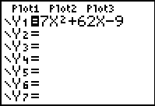
Adjust the graphing window to the settings shown. And press  to view the graph. | 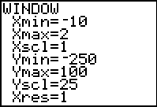
Press   Use the left and right arrows to move the cursor along the graph and locate the zeros.  Zeros of a polynomial are the x-values. The location (x, 0) is referred to as the x-intercept.  - How many zeros does this graph have?  - What are the zeros, approximately? | 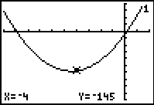
Notice that these zeros are not exact. This is a limitation of finding results graphically. To find the exact value of this zero (if it is rational), the Rational Zero Theorem must be applied.
The Rational Zero Theorem states that all potential rational zeros of a polynomial are of the form , where P represents all positive and negative factors of the last term of the polynomial and Q represents all positive and negative factors of the first term of the polynomial.
For this polynomial, , the possible rational zeros are:
We can find the exact zeros of the function by making a list. Press  then  and enter all of the potential zeros into L1. You should have 12 entries. | 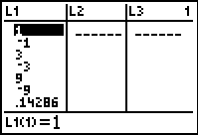
Highlight L2. Enter Y1(L1) and then press  to calculate the value of the function at each of these potential zeros. | 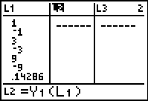
Scroll up and down the list. Where is the value of the function zero?
- What are the exact zeros of this function?

You can also calculate the zeros of a graph using the Zero command. Press    to open the Calculate menu and chose 2:zero. | 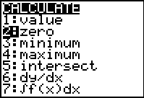
Move the cursor to the left of the zero and press . The move the cursor to the right of the zero and press  again. Then make a guess and press  again. The calculator displays the coordinates of the x-intercept.  - Use the zero command to check your answers. | 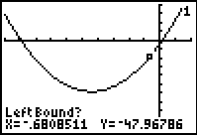

Problem 2 – Zeros of a cubic function
In this problem, you will find the zeros of a cubic function. Enter the function f(x) = 7x³ + 26x² - 92x + 24 in Y1. | 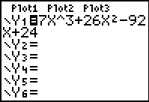
Adjust the graphing window to the settings shown. | 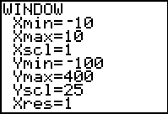
Trace the graph and locate the zeros.  - How many zeros does this graph have?  - What are the zeros, approximately? | 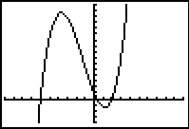
- Identify all the possible rational zeros using the Rational Zero Theorem  Enter these results in L1. (There should be 32 entries.)  - What are the zeros of this function?  - Use the zero command to check your answers. | 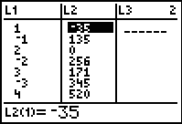

Exercises
1. Use the method described in the activity to find the rational zeros for .

2. How could synthetic division be used to help find the other zeros for the polynomial in Exercise 1? Use this to find the other zeros.

3. Is it possible for a polynomial to not have any rational zeros? or any zeros
at all? Explain.

4. An object that is launched vertically from a point above the ground at an initial speed of feet per second. Its vertical distance above the ground is given by the equation. Determine how long an object with velocity of 300 ft/sec will stay in the air if thrown upwards from a height of 5 feet.

