Problem 1 – Inequality Applied to Volume
If the area of the base of a cylindrical cup is 3 square inches, how high should you make the cup so it can hold at least 12 ounces of liquid? Don't make the cup taller than 10 inches, or it won't fit in the cabinet!

1. The goal is to make a cup with a volume of at least 12 fluid ounces (which is 21.65 in³).
How is this constraint written symbolically?

2. How is the constraint for the height of the cup written symbolically?

3. Since the volume of a cylinder is found using , what would the equation look like for the cylindrical cup? Hint: Use x for the height.

Now use the calculator to crunch the numbers of this equation to observe where the largest volume occurs, making sure that it will still be able to fit in the cabinet.  The first step is to change the table settings so that the calculator will ask you for the height. To do this press   and change the settings as shown at the right. | 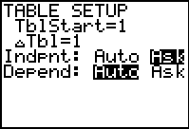
The second step is to enter the equation for the volume of the cup next to Y1 in the □ window,  Now press   and start entering values for the height. Observe the changes in volume (these will appear under Y1.) | 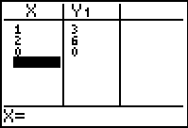
4. What is the minimum height for when the volume is at least 12 ounces? _______
5. Keeping the height at most 10 inches, what is the maximum volume for the cup? _______
6. Draw the solution to the height inequality on the number line below.
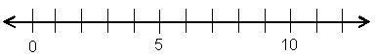

Problem 2 – Inequality Applied to Perimeter
Watch out! The length of a side of a rectangle cannot have a length of zero or smaller. For example, if a side of a rectangle is 2x – 6, then 2x – 6 > 0.

7. Solve for x in the inequality below.
2x – 6 > 0.

For the rectangle shown at the right, find all values of x for which the perimeter is at most 38.  8. Write an inequality for “perimeter is at most 38.”  9. Write an equation for the perimeter. | x – 5  x
Enter the equation from Question 10 next to Y1 in the □ window. Then press   and enter values for the length. Observe the changes in perimeter (these will appear under Y1). | 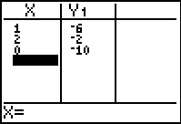
10. What is the minimum length, for when the perimeter is at least 0? __________
Remember: The length of a side cannot equal 0.
11. For what length is the perimeter the greatest? __________
12. Draw the solution to the inequality on the number line below. Then write an inequality expressing the solution of x.

Extension/Homework
Problem 3
The perimeter of a rectangle with sides 2x and x + 3 must be at least 42. Find all values of x where this is true.

Problem 4
A trapezoid has sides x, 2x + 3, 16 – x, and x.
- Since the length of each side must be greater than zero, write and simplify an inequality for each side. (This will let us know how small x can be.)

- Find all values of x so that the perimeter is less than 37.

