To begin, open up a blank Cabri Jr. document. Let’s start with a line segment, AB, and a point C above the segment.  Create a line through C that is parallel to . Construct a point on the new line and label it D. | 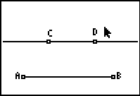
Hide the parallel line and complete the trapezoid. Measure the interior angles.  - Are the base angles at C and D congruent? Will they ever be? What about the base angles at A and B?  - Measure the lengths of the diagonals and . Will they ever be congruent? | 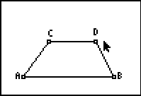
To verify that the lines are parallel, construct lines through C and D that are perpendicular to . | 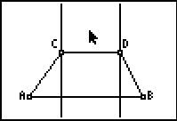
Construct the points of intersection of the new lines with . Construct lines segments to connect C and D to the line through and measure the lengths of these segments.  - Will these segments always be equal? Should they be? Why? | 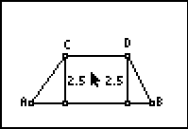
Label the new points on as E and F and measure the lenghts of and .  - Will ever be congruent to ? | 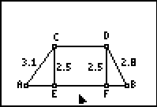
Try to drag point C or point D to make AC = BD. Due to the screen resolution, this can be very difficult. Construct and .  - For an isosceles trapezoid, these segments should also be congruent. Can you explain why? | 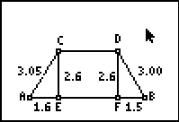
In order to construct an isosceles trapezoid, start with a line segment, AB. Construct the midpoint, M, and another point, P, on . Construct a line through the M that is perpendicular to . | 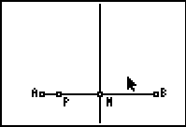
Press  and select the Reflection option. Click on the perpendicular line through M and then point P. | 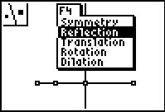
A new point will appear on the line segment on the right side. Label this point Q. | 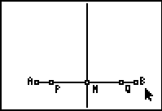
Construct perpendicular lines through P and Q. Construct point C on the perpendicular through P. | 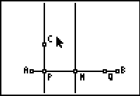
Construct a perpendicular to through point Q and a line through C that is parallel to . Construct point D at the intersection of these two lines. | 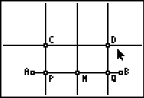
Hide the parallel and perpendicular lines and points M, P and Q. Complete the trapezoid and measure and .  - Explain why these line segments are congruent. | 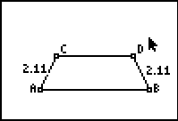
Measure the base angles—the interior angles at A, B, C and D.  - Which angles are congruent? Did you expect those angles to be congruent? Can you prove that they are? | 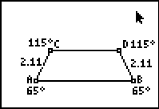
Construct and measure the lengths of the two diagonals and .  - Should they be congruent? Can you prove that they are? | 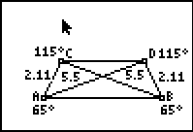
Drag point C and watch the angles and sides.  - Are all of the properties established above preserved? | 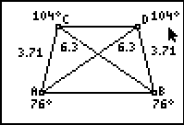
However, one property that is common to all trapezoids is that the line segment connecting the non-parallel sides is also parallel to these sides and its length is half the sum of the parallel sides. Construct a trapezoid ABCD. Construct the midpoints at E and F and construct . | 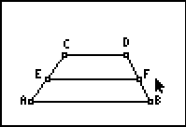
Measure the lengths of , and .  - How could you prove that is parallel to and ? | 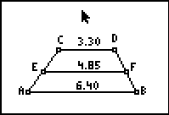
Use the Calculate tool to find the sum of the lengths of and . | 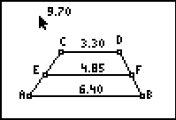
Place the number “2” on the screen and divide the sum by 2 using the calculate tool.  - Will this result always equal the length of ? Can you prove this result? | 