This activity looks at the finite (common) differences of polynomial functions and investigates the relationship between the constant value of finite (common) differences and the slope, or rate of change, of a line (or the leading coefficient of a quadratic function). | 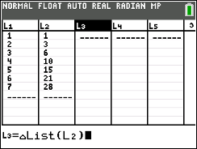

Below, there is a table of points (xc, yc) for a linear function. An interesting property for some functions is called the Finite Differences Method. The set of first differences is
$y_{2}-y_{1}, y_{3}-y_{2}, y_{4}-y_{3}$ (the value of y minus the previous value of y) over consecutive equal-length input-value intervals (when the x-values increase by the same amount). In column C, enter the values of the first differences.

xc | yc | Differences
-3 | -14
-2 | -11
-1 | -8
0 | -5
1 | -2
2 | 1
3 | 4

1. What do you notice about the set of first differences?

Graph the ordered pairs from the table above. Find the equation of the linear function passing through these ordered pairs.
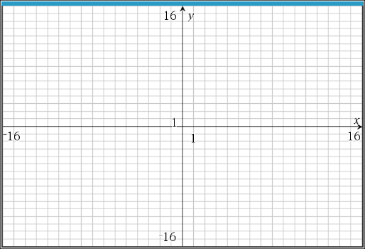

2. a. What do you notice about the set of first differences, the slope (rate of change) and the equation?
b. Use the linear equation f(x) = mx + b to explain the relationship between the set of first differences and the slope. (Hint: Consider how the value of the function changes for any x and x + 1.)

3. a. Using the table below, find the differences until they are equal.
First Differences
-14 – (-9) = -5
xc | yc
-3 | -14
-2 | -9
-1 | -4
0 | 1
1 | 6
2 | 11
3 | 16

b. Graph the set of ordered pairs above and find the equation of the linear function.

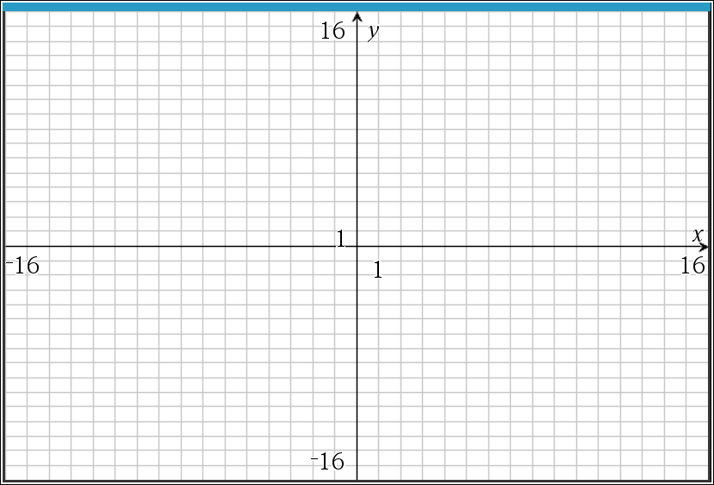
c. Is the slope (rate of change) related to the differences?

4. a. Using the table below, find the differences until they are equal.
First Differences
1 – (-1) = ___
xc | yc
-6 | -1
-4 | 1
-2 | 3
0 | 5
2 | 7
4 | 9
6 | 11

b. Graph the set of ordered pairs above and find the equation of the linear function.

c. What is the relationship between the first set of differences (when the x-value
increases by something other than 1) and the rate of change of the line? Explain.

5. a. Using the table below, find the differences until they are equal.
First Differences
4 – 7 = ____
xc | yc
-3 | 7
-2 | 4
-1 | 1
0 | -2
1 | -5
2 | -8
3 | -11

b. Graph the set of ordered pairs above and find the equation of the linear function.
c. When the first set of differences is negative, what impact does that have on the
graph?

6. Looking at linear data, Meredith subtracted $y_{1}-y_{2}$ and found the constant set of first differences to be 5. Owen subtracted $y_{2}-y_{1}$ and found the constant set of first differences to be –5. What is the rate of change of the line, assuming that the x-values are increasing by 1? Explain why the order in which the subtraction is performed is important.

7. a. Using the table below, find the differences until they are equal.
First Differences Second Differences
3 – (12) = ___
xc | yc
-3 | 12
-2 | 3
-1 | -2
0 | -3
1 | 0
2 | 7
3 | 18

b. What do you notice about the set of first differences? Second differences?

This is the graph of the quadratic function with the set of ordered pairs from the table above.
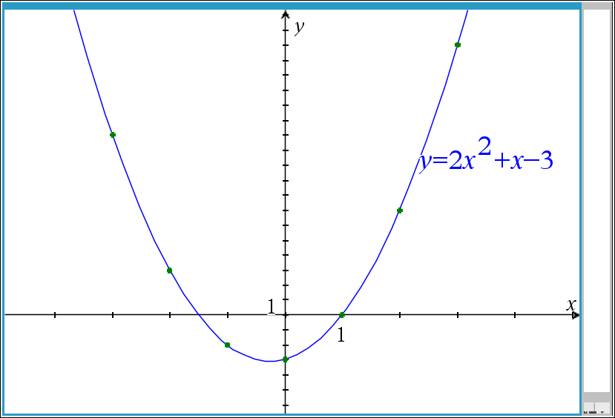
8. a. With an x-value increase of 1, what seems to be the relationship between the second differences and a, the leading coefficient in the equation?

b. Tanesia made a conjecture that the rate of change for the quadratic function is a linear function. Does her conjecture seem reasonable? Why or why not?

9. a. Using the table below, find the differences until they are equal.
First Differences Second Differences
-5 – (-12) = ___
xc | yc
-6 | -12
-4 | -5
-2 | 0
0 | 3
2 | 4
4 | 3
6 | 0

b. What do you notice about the set of first differences? Second differences?

This is the graph of the quadratic function with the set of ordered pairs from the table above.
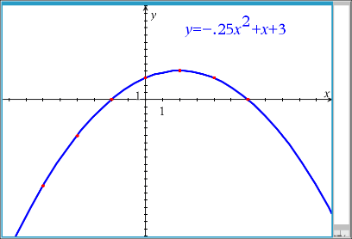

10. With an x-value increase of 2, what is the relationship between the second difference and a, the leading coefficient in the equation?

11. a. Using the table below, find the differences until they are equal.
First Differences Second Differences
9 – (25) = ___
xc | yc
-3 | 25
-2 | 9
-1 | -1
0 | -5
1 | -3
2 | 5
3 | 19

b. What do you notice about the set of first differences? Second differences?

This is the graph of the quadratic function with the set of ordered pairs from the table above.
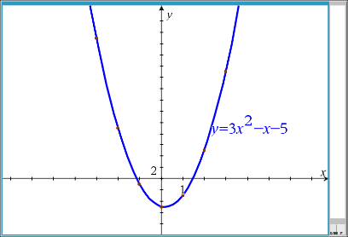

12. Regardless of the x-value increase, what is the relationship between the second difference and a, the leading coefficient in the equation?

13. Revisit the three quadratics from questions 7 - 12. Remember what you learned earlier about the relationship between the sign of the leading coefficient a and the direction in which the quadratic opens.
a. Make a prediction about the relationship between the constant difference and the sign of the leading coefficient, a.

b. Use the graph of the function and what you know about the rate of change of a quadratic function to explain why your prediction is reasonable.

14. Using the table below, predict how many subtractions it will take until the differences are
constant.
xc | yc
-3 | -16
-2 | -3
-1 | 0
0 | -1
1 | 0
2 | 9
3 | 32

The points in the table above are from a cubic equation.
15. Which set of finite (common) differences would be a constant for a polynomial of n^{th} degree? Explain your reasoning.

16. Summarize your results from the investigation.
a. For a linear function, if the first set of differences is a positive constant, the graph ______________________________.

b. For a linear function, if the first set of differences is a negative constant, the graph ______________________________.

c. For a quadratic function, if the second set of differences is a positive constant, the graph ______________________________.

d. For a quadratic function, if the second set of differences is a negative constant, the graph ______________________________.
15. Let’s use technology to find your common differences. Using the table below, press stat, edit and enter the following values into the first two columns, $L_{1} and L_{2}$.

$$L_{1}$$ | $$L_{2}$$
1 | 1
2 | 3
3 | 6
4 | 10
5 | 15
6 | 21
7 | 28

To find the common differences on the handheld, move your cursor to the column top titled $L_{3}$. Press 2nd stat (list), OPS, 7: $∆List (L_{2})$, enter. Find the differences of these first differences in $L_{4}$ by repeating the process completed in $L_{3}$.
Using your knowledge gained from this activity while comparing common differences, explain the function that this table represents and explain how you came to that conclusion.

18. a. Using the table below, find the 1st, 2nd, and 3rd common differences. What is different about the
sets of finite (common) differences and the graph of this function, compared to the others you
have looked at in this activity?
xc | yc
-3 | 0.125
-2 | 0.25
-1 | 0.5
0 | 1
1 | 2
2 | 4
3 | 8

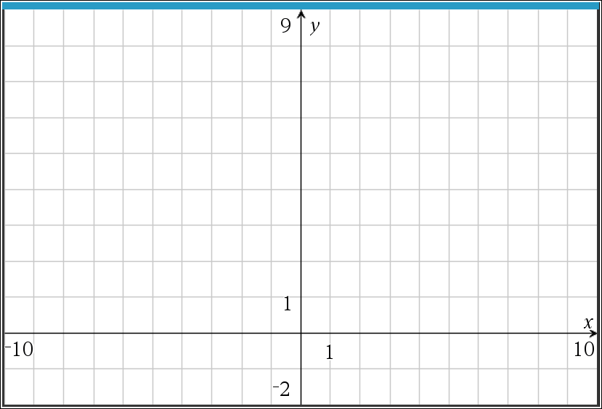

b. Explain why the pattern of differences repeats in the way it does.

c. What type of function do you think fits this data? Describe the relationship between this table and
the function you predict it is.

