A large pond contains 300 guppies and 160 frogs.
Suppose the guppy population increases by 25 guppies per year.
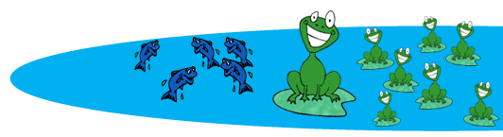
Suppose the frog population increases by 25% per year.
- What does the future hold for this pond? Make a prediction.

- What factors might impact the growth of the guppy and frog populations?

- Use the words NOW and NEXT to write a rule showing how the guppy population changes each year. On the home screen of your calculator, simulate 6 years of guppy growth.  - Let the function G represent the guppy population at year t. Complete the table.  - How does the guppy population change every 2 years?
  Year, t | Guppies, G
  0
  1
  2
  3
  4
  5
  6
- Graph the data (t, G) on the set of axes provided. Then, connect the data points.
- Write a formula to model the population growth.

500
400
300
200
- Use your formula to predict the population
100
at year t = 10.
0 2 4 6 8 10

- The initial population of 160 frogs grows by 25% each year.
Suppose the rectangle below represents a population of 160 frogs.
160
On the grid below, the total rectangle represents the population after the first year of 25% growth.

What is the population of frogs at year t = 1? ___________

- On the grid below, the model represents the population after 1 year.
Use the grid to represent the population after 2 years.

What is the population of frogs at year t = 2? ___________
Does the population increase by the same number of frogs each year? Explain your answer.

- Use the words NOW and NEXT to write a rule showing how the frog population changes
each year. On the home screen of your calculator, simulate 6 years of frog growth.

- Interpret the meaning of the population at year t = 3 in terms of the context of the situation.
- Let the function F represent the frog population at year t.
Write a formula that models the population growth of frogs.
- Use the table feature of your calculator to validate your formula.
Draw the graph of the frog population on the set of axes on the previous page.
- In what year does the population of frogs overtake the population of guppies?

- List any limitations of these models for population growth.

