Activity Overview  In this activity, students will perform trigonometric proofs and use the graphing capabilities of the calculator for verification.  Topic: Trigonometric Identities  - Use fundamental trigonometric identities to prove more complex trigonometric identities.  - Verify trigonometric identities by graphing.  Teacher Preparation and Notes  - Students should already be familiar with the Pythagorean trigonometric identities as well the fact that tangent = sine/cosine, cosecant = 1/sine, secant = 1/cosine, and cotangent = 1/tangent.  - To download the student worksheet, go to education.ti.com/exchange and enter “9776” in the keyword search box.  Suggested Related Activities  To download any activity listed, go to education.ti.com/exchange and enter the number in the keyword search box.  - An Interesting Circle (TI-NspireTM technology) — 11176  - Graphs of Sine, Cosine, and Tangent (TI-NspireTM technology) — 8314  - Trigonometric Patterns (TI-84 Plus family) — 12434  - Ferris Wheel Ride (TI-NspireTM technology) — 10088  - Trigonometric Ratios (TI-84 Plus family) — 9534 | 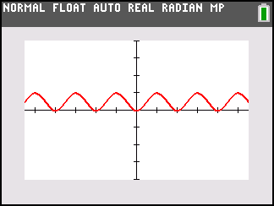  This activity utilizes MathPrintTM functionality and includes screen captures taken from the TI-84 Plus C Silver Edition. It is also appropriate for use with the TI-83 Plus, TI-84 Plus, and TI-84 Plus Silver Edition but slight variances may be found within the directions.  Compatible Devices:  - TI-84 Plus Family  - TI-84 Plus C Silver Edition  Lesson Files:  - TrigProofs_Student.pdf  - TrigProofs_Student.doc  Click HERE for Graphing Calculator Tutorials.

Problem 1 – Using the Calculator for Verification
Prove: (1 + cosx)(1 – cosx) = sin²x.
(1 + cos(x))(1 – cos(x)) = 1 – cos²(x)
= [sin²(x) + cos²(x)] – cos²(x)
= sin²x
To verify this proof graphically, you will determine if the graph of the expression on the left side of the equation coincides with the graph of the expression on the right side of the equation.
Enter the left side of the equation (1 + cosx) (1 – cosx) in Y1. Enter the right side of the equation (sin x)² in Y2. | 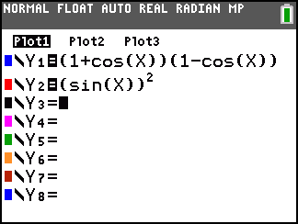
Press  and select ZTrig to set the window size. | 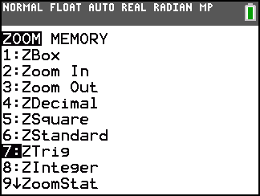
The second graph (red graph) covers the first graph (blue graph), so the two sides of the equation are equal, as proved. Note that the calculator is only verifying what has been proven. The graph by itself does NOT constitute a proof.
For problems 2 through 5, prove the equation given, and then verify it graphically. For cotx, type (1/tanx). For secx, type (1/cosx).
2. sinx · cotx · secx = 1
3.
4. tanx + cotx = secx(cscx)
5.
Solutions
2.
3.
4.
5.

