To Toss or To Simulate?  ID: 11610 | Time required  20 minutes

Activity Overview
In this introductory activity, students will use the RandInt() command to simulate the tossing of a coin and the rolling of a die. They will collect data for several trials and use the information to investigate the Law of Large Numbers.

Topic: Simulations
- Random Integers
- Experimental Probability
- Theoretical Probability
- Law of Large numbers

Teacher Preparation and Notes
- This lesson is designed as a discovery lesson that is teacher led. A worksheet has been provided to help organize data collection.
- To download the student worksheet, go to education.ti.com/exchange and enter “11610” in the keyword search box.

Associated Materials
- TossOrSimulate_Student.doc

Suggested Related Activities
To download any activity listed, go to education.ti.com/exchange and enter the number in the keyword search box.
- Probability Simulations (TI-Nspire technology) — 9328
- How Random! (TI-84 Plus family) — 9291
- Rolling a Two (TI-Nspire technology) — 10211
- Law of Large Numbers: Adding it Up (TI-84 Plus family) — 4238
- Law of Large Numbers: A Weighty Decision (TI-84 Plus family) — 4236

Problem 1 – Tossing a coin
At the beginning of the activity define and discuss an event and sample space.
Students will be using the Random Integer (randInt) command to simulate the tossing of a coin. Ask them why sometimes a simulation is more practical than a hands-on experiment.
- How could you use numbers to represent a coin toss?
- The command randInt() that randomly generates integers. How could it be used to simulate the flipping of a coin?
In this part of the activity, they will use 0 and 1 to represent the sides of the coin. However, any two consecutive integers can be used.  Students will compare the difference between entering the command randint(0,1) five times and entering randint(0,1,5). They should see that they calculate the same thing but the latter does it all at one time.  The syntax for the Random Integer command is randInt(LowBound, HighBound) OR randInt(LowBound, HighBound, number of trials). | 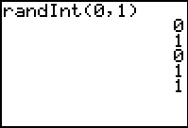  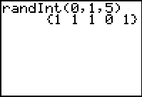
Before students perform the experiment for 10 and 20 trials, ask them what number of heads they expect to get. Then after running the experiment, poll the students to see how many heads they actually tossed. Discuss why the results differ.
The experimental coin tossing will be simulated using lists. Since 1 represents heads, the sum command will return the number of heads in a simulation. On the Home screen, students are to enter sum(randInt(0, 1, numtrials)), where numtrials changes to reflect the number of tosses. | 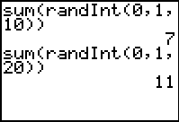
If using Mathprint OS:
Students find the sum of tosses multiple times. They can use the up arrow key () to highlight a previous entry and then press  to place it on the current entry line and edit the value of the numtrials (number of tosses).
Optional:  If students are more advanced, they can enter sum(randInt(0, 1, numtrials))→L1(#), where they would change numtrial to reflect the number of tosses and # to reflect the row number in the table. This will store the number of heads in list L1.  The arrow is entered by pressing . | 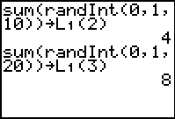
If using Mathprint OS:  The entries will run off the right side of the screen and an arrow indicates that the entry continues. If students wish to be able to see the entire entry on the screen, they can press  and press enter on CLASSIC. | 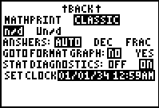
Students will generate the data and then enter all of the data into the lists ( ).  L1: the numbers of heads  L2: numbers of tosses  L3: percent of heads (L1/L2)  Make sure students understand that L3 is the number of heads divided by the number of trials | 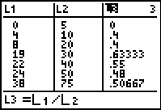
After all the data is collected, students will then use the data to create a scatter plot of the percent of heads versus the number of trials. | 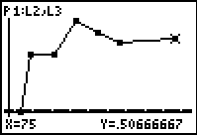
For students to better see that the experimental probability approaches the theoretical probability, have them add a horizontal line at 0.5. To do this, they will graph Y1 = 0.5. | 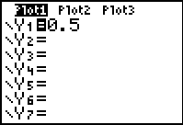
Discussion Points:
- What is the theoretical probability of obtaining a head when tossing a coin?
- What happens to the percent of heads as the number of trials increases?
- This is called The Law of Large Numbers. It says that as the number of trials increases, the experimental probability of an event will approach the theoretical probability.

Problem 2 – Rolling a die
This problem can be done in pairs during class, where one student perform the simulation and the other records the data, or as a homework problem.
Students will simulate the rolling of a six-sided die using the randInt command but they cannot use the sum command because some of the integers will be greater than 1.
Explain to students that the command randInt(1,6) returns an integer between 1 and 6. So when it was randInt(0,1) there are only two possibilities because there are no integers between 0 and 1.
On the Home screen, students are to enter randInt(1,6,numtrials)→L1 where numtrials changes to reflect the number of rolls. They will then need to sort list L1. | 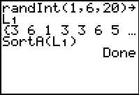
Students will need to determine the number of 6s rolled by looking at list L1. When the number of rolls is small they can count by hand, but as the number of rolls gets larger they will need to take the difference of the rows where the first and last 6s are.  For example, if the first 6 is at L1(16) and the last 6 is at L1(20), it is 20 – 16 + 1 = 5. | 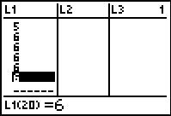
Once students have gathered all of their data, they can enter it into the lists. They will need to clear the data in list L1 first (arrow to the top of L1 and press  ).  L1: the numbers of 6s  L2: numbers of rolls  L3: percent of 6s (L1/L2) | 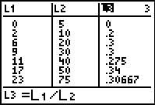
Students can then follow Problem 1 to set up and graph a connected scatter plot of percents of 6s versus number of rolls.  Having students plot the theoretical probability on the scatter plot will reinforce the concept of the activity. | 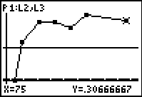
By the end of this activity, students should see that the experimental probability gets closer and closer to the theoretical probability as the number of trials (tosses, rolls, etc) increases. Introduce the formal concept of Law of Large Numbers.

Extension – Rolling two dice and recording a sum
This problem can be done in pairs during class or as a homework problem.  Challenge students to simulate the rolling of two dice and finding the sum. Record the number of sums that are 7. They will be tempted to use integers from 2 – 12. However, this does not take into consideration that each sum does not have an equal probability of being chosen.  Students are to use the command (randInt(1,6,numtrials)+randInt(1,6,numtrials))→L1 to generate the sum of the rolls. They will need to sort list L1 and then determine the number of 7s in the same manner students found the number of 6s in Problem 2.  Having students plot the theoretical probability on the scatter plot will reinforce the concept of the activity. | 