Math Objectives  - Students will examine the relationship between the first and second derivative and shape of a function.  Activity Types  - Student Exploration  - Group Activity  About the Lesson  - The students will move a point on a given function and observe the sign of the first and second derivative as well as a description of the graph (increasing, decreasing, concave up, concave down). From their observations, students will make conjectures about the shape of the graph based on the signs of the first and second derivative.  Directions  - Grab and move the point on the graph and note the description at the bottom of the page to answer the questions. | 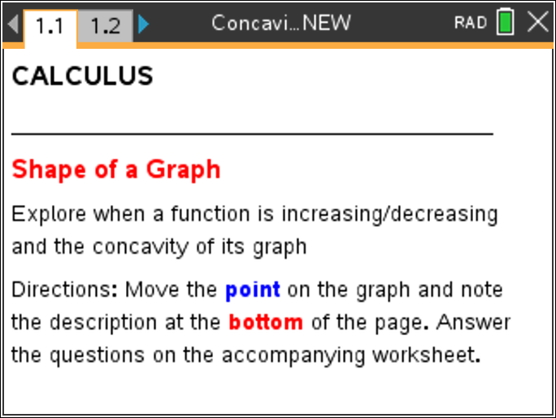  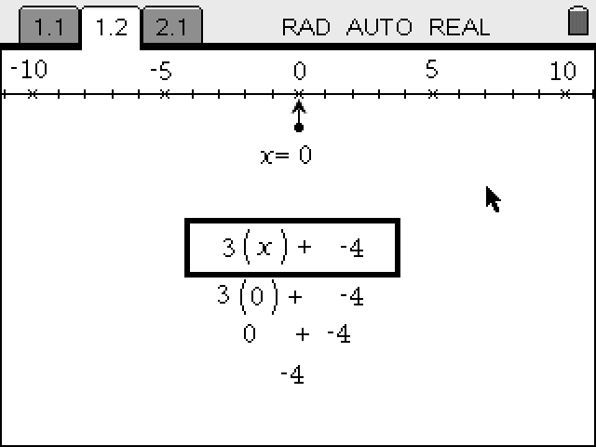  TI-Nspire™ Technology Skills:  - Download a TI-Nspire document  - Open a document  - Move between pages  - Grab and drag a point  Tech Tips:  - Make sure the font size on your TI-Nspire handheld is set to Medium.  - You can hide the function entry line by pressing /G.  Lesson Materials:  Student Activity  Concavity_CAS_Student.pdf  Concavity_CAS_Student.doc  TI-Nspire document  Concavity_CAS.tns  Visit www.mathnspired.com for lesson updates.

Discussion Points and Possible Answers

Move to page 1.2.
PART I:
Move the point on the graph at the top of the screen and record a point on the function that meets each of the following criteria:

Criteria | Point
Increasing, Concave Up

Increasing, Concave Down

Decreasing, Concave Up

Max or Min, Concave Up or Down  (2 points) | Maximum Concave Down  Minimum Concave Up

1. Compare your points with another classmate’s. Work together to determine if you can find the range of x-values where the function is:

a. Concave Up

Answer:

b. Concave Down

Answer:

c. Increasing

Answer:

d. Decreasing

Answer:

Teacher Tip: Once students have found sample points, discuss the shape of the graph and how it matches the descriptions of increasing/decreasing and concave up/concave down.
After the class discussion, have students work in pairs or groups to determine the x values for where the function meets the conditions: concave up, concave down, increasing, and decreasing.
Question students in groups to find how they are determining the appropriate range and what characteristics of the graph may be helping them.

PART II:
Students use the graph trace to find the maximum, minimum, and point of inflection of the graph. Students must then observe the characteristics of the graph at the point as well as to the left and right of the point to determine any possible relationships.
Directions: Turn on the Geometry Trace: Menu > Trace > Graph Trace. Press ? to find the letters that will help you find the following parts of the graph.
2. Record the points below, then describe what the graph is doing using increasing, decreasing, concave up, concave down at the point and immediately to the left and right of the point.
a. Maximum
Answer: concave down at that point. Increasing to the left and decreasing to the right
b. Minimum
Answer: concave up at that point. Decreasing to the left and increasing to the right
c. Point of Inflection

Answer:

3. Based on your observations, describe how the sign of the derivative helps you determine when function has a:
a. Maximum
Answer: The derivative changes from positive to negative.
b. Minimum
Answer: The derivative changes from negative to positive.

c. Point of Inflection

Answer: The point of inflection is where the graph changes concavity.

Extension:
Use Scratchpad to graph the function. Using this graph, determine where/if the anti-derivative function will have a maximum, minimum, or point of inflection.

Answer: Maximum: at x = –1
Minimum: at x = 3
Point of Inflection: at x = 1

Teacher Tip: Lead students developing the conditions for using the derivative to determine when a function has a maximum, minimum, and point of inflection. The extension question can be used a formal or informal assessment of student understanding.

