About the Lesson  - This lesson is aligning with the curriculum of IB Mathematics Approaches and Analysis SL/HL  - This falls under the IB Mathematics Content Topic 5 Calculus:  5.6a Derivative of x^{n}, sin x, cos x, e^{x}, and ln x.  5.12b Definition of derivatives from first principles  As a result, students will:  - Develop the idea of the derivative as a function  - Gather evidence toward some common derivative formulas  - Use numerical and graphical investigations to form conjectures  Vocabulary  - derivatives  - symmetric difference quotient  Teacher Preparation and Notes  - Students can complete this activity independently but may benefit from the discussion that occurs when working in a small group.  - Students will investigate the derivatives of sine, cosine, natural log, and natural exponential functions by examining the symmetric difference quotient at many points using the table capabilities of the graphing handheld.  - This activity promotes the transition to thinking about the derivative as a function by approximating the derivative at a point action repeatedly, building up a derivative approximation function over a discrete domain.  - Students should be able to graph and modify (zoom, trace, and so on) graphs of functions and generate tables on the graphing handheld.  - This activity should be done after the derivative at a point has been studied.  - Students should be able to investigate other derivative formulas using the same technique.  - Students may have to be reminded that the symmetric difference quotient merely approximates the derivative at a point, but can be more precise than the formal process of finding a derivative.  - Students may have a difficult time predicting the derivative function on the basis of numerical evidence at first. The first questions are meant to ease them into the process.  TI-Nspire™ Navigator™ System  - Send out the Investigating Derivatives.tns file if you want the students to answer questions on the Nspire.  - Monitor student progress using Class Capture.  - Use Live Presenter to spotlight student answers.  Activity Materials  Compatible TI Technologies:  TI-Nspire™ CX Handhelds,   TI-Nspire™ Apps for iPad®,  TI-Nspire™ Software | 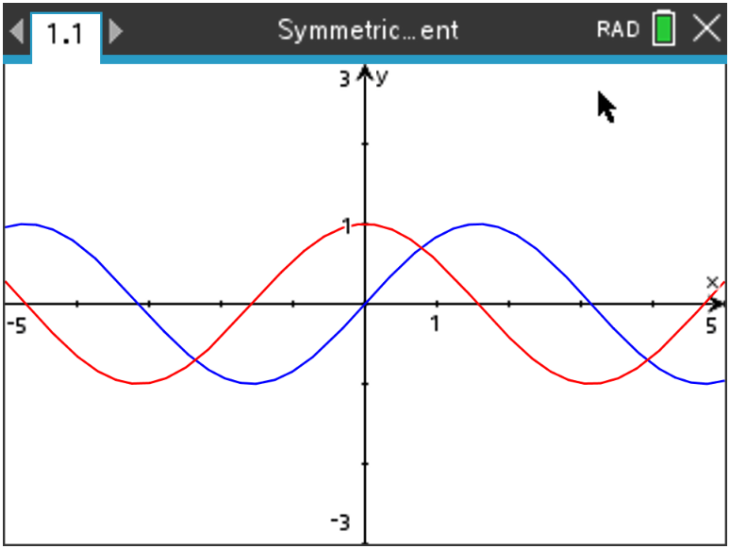  Tech Tips:  - This activity includes screen captures taken from the TI-Nspire CX II handheld. It is also appropriate for use with the TI-Nspire family of products including TI-Nspire software and TI-Nspire App. Slight variations to these directions may be required if using other technologies besides the handheld.  - Watch for additional Tech Tips throughout the activity for the specific technology you are using.  - Access free tutorials at http://education.ti.com/  calculators/pd/US/Online-Learning/Tutorials  Associated Materials:  - Investigating Derivatives of Some Common Functions_Student-Nspire.pdf  - Investigating Derivatives of Some Common Functions_Student-Nspire.doc
One of the many ways in which you can think of a derivative is as a function that uses x as an input and returns the slope of the line tangent to f at x. The derivative of a function is often another function with a formula that can be used and applied. In this activity, you will investigate the derivatives of some common functions by approximating the instantaneous rate of change (using the symmetric difference quotient) at many inputs. You will also use the table and graphing capabilities of your graphing handheld.

Throughout this activity, make sure your handheld is in Radian mode.
Teacher Tip: This might be a good time to refresh student memories about the difference between Radian and Degree modes on the handheld. Also, the topic of symmetric difference quotient is not always taught in higher level math classes and may need some introduction before starting this activity.
Problem 1 –
In this first problem, we will investigate the derivative of with the table on your handheld and the symmetric difference quotient.

1. (a) Input the equation .  (b) Build a virtual slope finder into . This slope finder will use the symmetric difference quotient  (with h = 0.001) to approximate the instantaneous rate of change of the function stored in .  (c) Input this into : 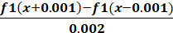  (d) Set up the table as shown in the screen shot here.  (Note: Step = 0.1)  (e) View the table.  (f) The first column (X) contains the input values, the second column () contains the output of  at the corresponding input value, and the third column () contains the  approximation of the derivative of at the corresponding input value. Now, try to find a  common function that has outputs close to the values in the third column.  Answer:  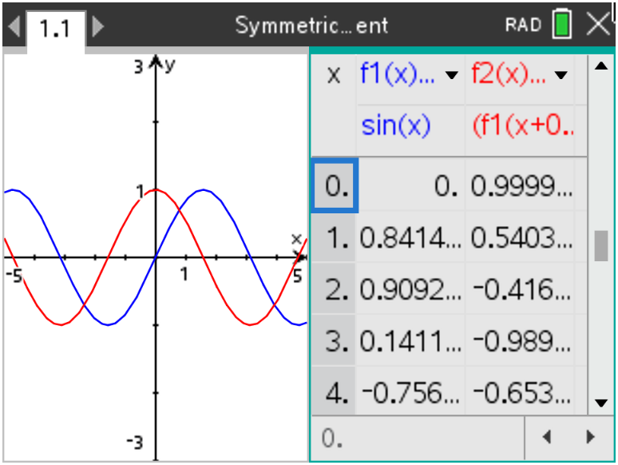 |  |  | 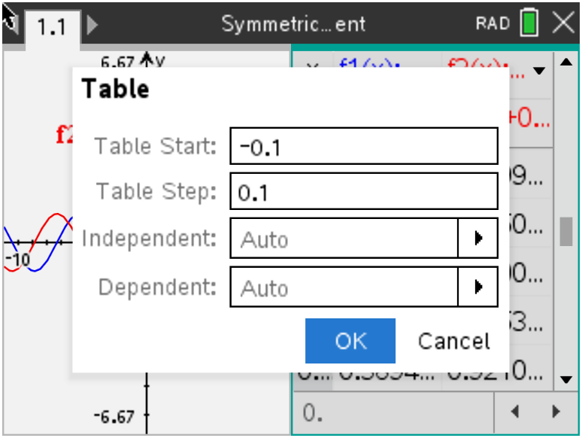
2. State the maximum value of in the table. State the  minimum value of in the table.  Answer: Max: 1; Min: -0.991  3. State the input values the first three positive roots of fall.  Answer: Between 1.5 and 1.6 ( approx. π/2); between 4.7 and 4.8 (approx. 3π/2); and between 7.8 and 7.9 (approx. 5π/2)  4. State the common function you predict to be .  Answer:  Use your graphing handheld to generate a graph of f and the symmetric difference quotient for f (graph and). Use the following suggested window settings.  5. State if the graph of the symmetric difference quotient for f looks  like the graph of the function that you answered in Question 4. If  not, state your new prediction for .  Answer: |  | 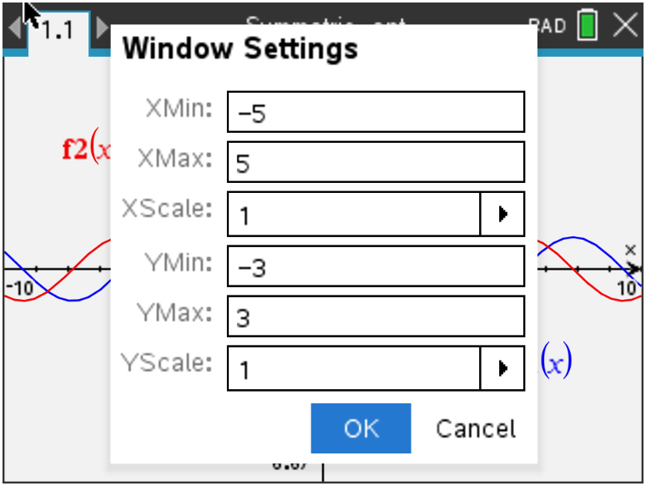
To see how close your prediction for is to the symmetric difference quotient of f, store the function that is your prediction for the derivative of f into, and look at the table.  6. Describe how close your prediction of is to the symmetric  difference quotient. State how many decimal places they match  for most entries.  Answer: The agreement is generally about six decimal places.  The advantage of building a general slope finder in based only on is that the process can be applied to investigate the derivatives of other functions by merely changing.  Problem 2 –  Input as , and look at the table.  7. State your prediction for . Explain.  Answer:  Notice that the symmetric difference quotient appears to be near 0 when x = 0 and that it decreases until x is between 1.5 and 1.6 (approx. π/2). The symmetric difference quotient also changes sign when x is between 3.1 and 3.2 (approx. π). This is similar to the behavior of –sin(x).  Use your graphing handheld to generate a graph of f and the symmetric difference quotient for f ( and ).  8. State if the graph of the symmetric difference quotient for f looks  like the graph of the function that you predicted in Question 7. If  not, state your new prediction for .  Answer:  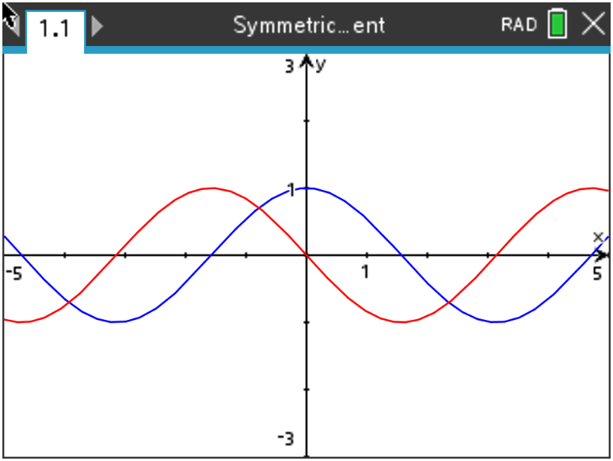 |  | 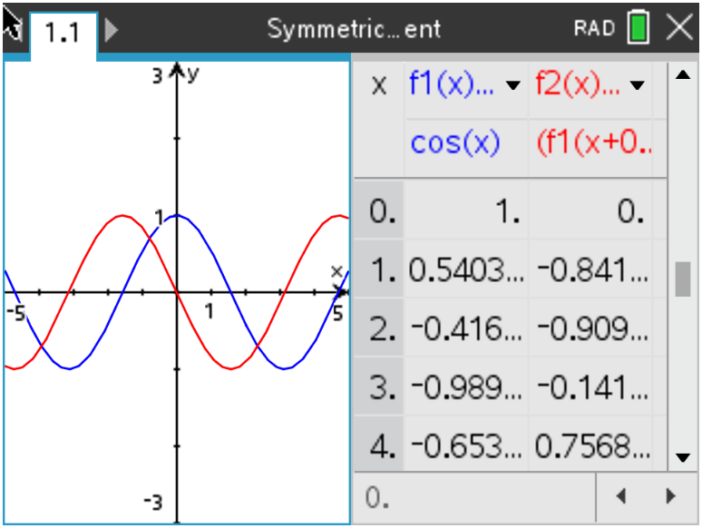
Store the function that is your prediction for the derivative of f into , and look at the table.  9. State how close your prediction of is to the symmetric  difference quotient. State how many decimal places they match  for most entries.  Answer: The agreement is generally about six decimal places.  Problem 3 –  Input as , and look at the table.  10. State your prediction for . Explain.  (Hint: Look at the x and columns.)  Answer: 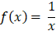  The symmetric difference quotient appears to always be nearly the reciprocal of the x column.  Use your graphing handheld to generate a graph of f and the symmetric difference quotient for f ( and ).  11. State if the graph of the symmetric difference quotient for f looks  like the graph of the function that you predicted in Question 10.  If not, state your new prediction for .  Answer:  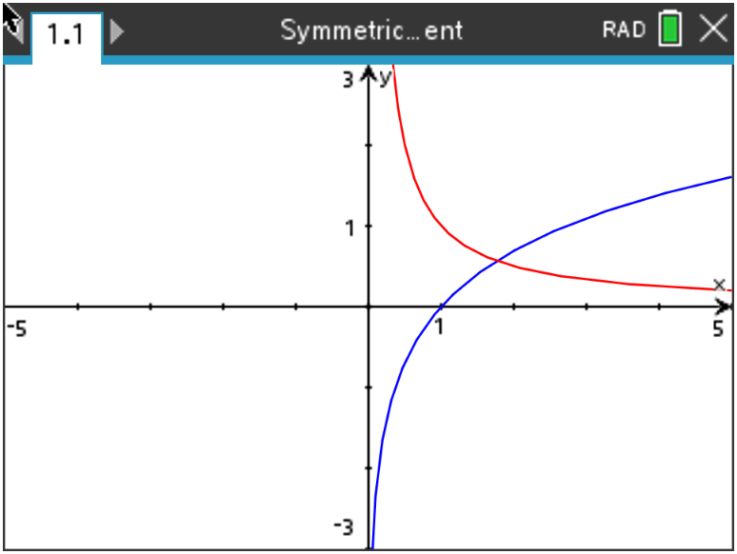  Store the function that is your prediction for the derivative of f into , and look at the table.  12. State how close your prediction of is to the symmetric  difference quotient. State how many decimal places they match  for most entries.  Answer: The agreement is generally about six decimal places. |  | 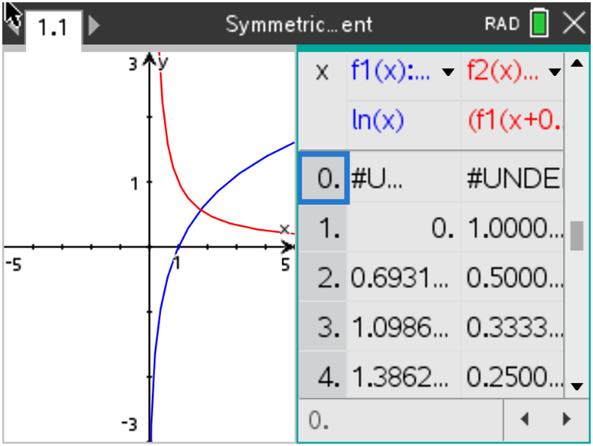
Problem 4 –  Finally, input as , and look at the table.  13. State your prediction for . Explain.  Answer:  The column and the column appear to be about equal. In other words, the values of f closely match the values of the symmetric difference quotient.  Use your graphing handheld to generate a graph of f and the symmetric difference quotient for f ( and ).  14. State if the graph of the symmetric difference quotient for f looks  like the graph of the function that you predicted in Question 13. If  not, state your new prediction for .  Answer:  Yes, the graphs of f and the symmetric difference quotient are practically indistinguishable.  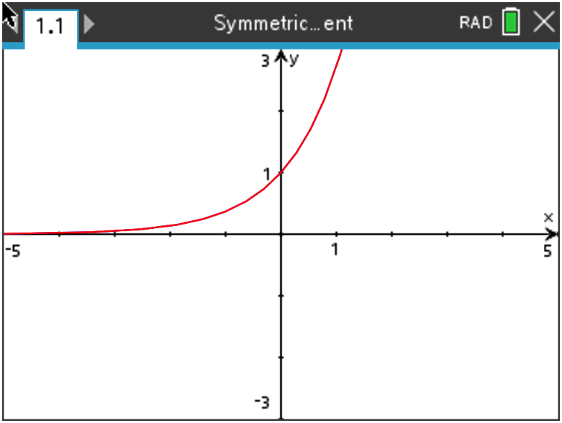  Store the function that is your prediction for the derivative of f into , and look at the table.  15. State how close your prediction of is to the symmetric  difference quotient. State how many decimal places they match  for most entries.  Answer: The agreement is generally about five decimal places. |  | 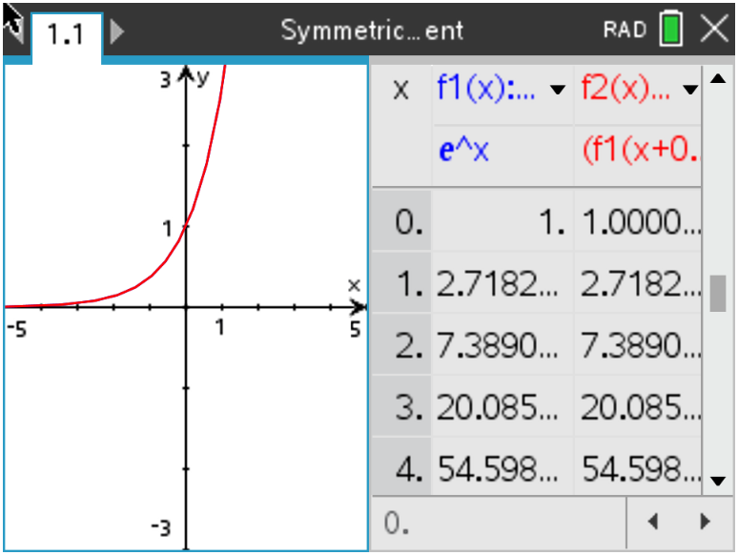
Ticket Out the Door –

16. Write a short paragraph summarizing what you have learned from this activity. Include all
derivative formulas that you have conjectured.

Answer: Answers will vary. Students should mention that they used the symmetric difference quotient at many points to develop formulas for the derivatives of sine, cosine, natural log, and natural exponential functions. They should state these formulas.

**Note: This activity has been developed independently by Texas Instruments and aligned with the IB Mathematics curriculum, but is not endorsed by IB™. IB is a registered trademark owned by the International Baccalaureate Organization.

