Math Objectives  - Students will determine when a function has a maximum or minimum based on the derivative of the function.  - Students will look for and make use of structure. (CCSS Mathematical Practice)  - Students will construct viable arguments and critique the reasoning of others. (CCSS Mathematical Practice)  Activity Types  - Student Exploration  - Group Activity  About the Lesson  - Students will explore several functions and make conjectures about the relationships between maximums, minimums and zeroes of a function and its derivative.  TI-Nspire™ Navigator™ System  - Send out the Maximum_Minimum_Zeroes.tns file.  - Monitor student progress using Class Capture.  - Use Live Presenter to spotlight student answers.  Activity Materials  - Compatible TI Technologies:  TI-Nspire™ CX Handhelds,   TI-Nspire™ Apps for iPad®,  TI-Nspire™ Software | 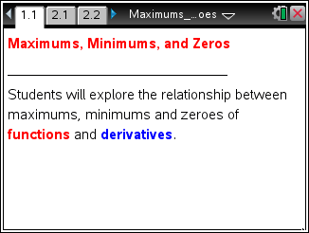  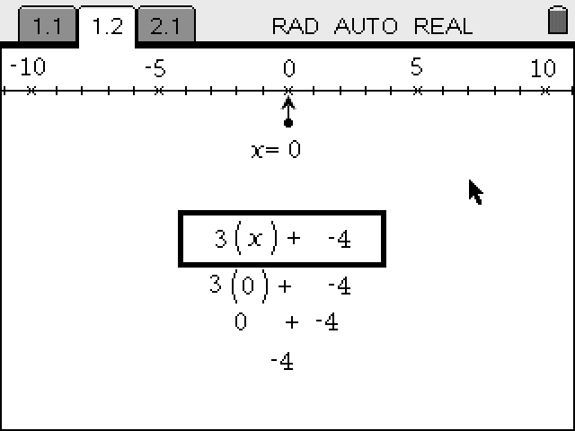  Tech Tips:  - This activity includes class captures taken from the TI-Nspire CX handheld. It is also appropriate for use with the TI-Nspire family of products including TI-Nspire software and TI-Nspire App. Slight variations to these directions may be required if using other technologies besides the handheld.  - Watch for additional Tech Tips throughout the activity for the specific technology you are using.  - Access free tutorials at http://education.ti.com/  calculators/pd/US/Online-Learning/Tutorials  Lesson Files:  Student Activity  - Maximum_Minimum_Zeroes_Student.pdf  - Maximum_Minimum_Zeroes_Student.doc  TI-Nspire document  - Maximum_Minimum_Zeroes.tns

Discussion Points and Possible Answers
- Grab and move the open circle on the graph to the points indicated on the student worksheet. Next, make a conjecture about the relationships seen. Note: Students may also move with the slider, however the words asked for below will NOT show when using a slider.
- The function that is graphed with a thicker line is the anti-derivative function. The other function is the graph of the derivative.
- The dotted vertical line is a perpendicular line will help record coordinates from both functions

Move to page 2.1.

Tech Tip: If students experience difficulty dragging a point, make sure they have not selected multiple objects. Press d to release points. Use e to select the desired point if necessary. Check to make sure that they have moved the arrow until it becomes a hand (÷) getting ready to grab the point. Then press / x to grab the point and close the hand ({).
Tech Tip: : If you are having difficulty moving the correct point, long tap once on the point to display the “select object” menu, and then select the desired point. When you move the open circle to the desired location, either the word maximum, minimum or zero will appear in a grey box. Upon releasing your finger, the word will disappear.
Teacher Tip: The student worksheet explains the steps students need to follow in order to record data and make a conjecture.

Answers: 1. Maximum: (-0.8685, 0.000)
2. Zeroes: (–2, 12), (1, –3), (2, 4)
3. Minimum: (1.5352, 0.000)

Move to page 2.2.
Answers: 4. Zeroes: (–0.869, 6.06), (1.54, –0.879)
5. Minimum: (0.333, 2.59)
6. Conjecture: Maximum and minimum points on the function are zeroes of the derivative.
Testing Your Conjecture

Move to page 3.1.

Teacher Note: This problem should contradict the minimum and zero relationship students may have noticed in problem 2.

Test your conjecture by moving the empty circle to all off the maximums, minimums, and zeroes on the function as in problem 2.1. Record the coordinates in the table on the following page. Do the same for problem 3.2 by moving the empty circle as you did in problem 2.2. Note: Students may also move with the slider, however the words asked for below will NOT show when using a slider.

Answers:

Problem 3.1 |  |  | Problem 3.2
Type of Point | Coordinate |  | Type of Point | Coordinate
Zero | (–9.42, 1) | ` | Maximum | (–9.42, 0)
Maximum | (–7.854, 1) |  | Zero | (–7.854, 1)
Zero | (–6.28, –1) |  | Minimum | (–5.93, –0.34)
Minimum | (–4.71, 0) |  | Zero | (–4.71, –1)
Zero | (–3.14, 1) |  | Maximum | (–3.14, 0.000)
Maximum | (–1.57, 0) |  | Zero | (–1.57, 1)
Minimum | (0, 0) |  | Minimum | (–0.001, 0.00)
Maximum | (1.57, 0) |  | Zero | (1.57, 1)
Zero | (3.14, –1) |  | Minimum | (3.14, 0)
Minimum | (4.71, 0) |  | Zero | (4.71, –1)
Zero | (6.28, 1) |  | Maximum | (6.28, 0.00)
Maximum | (7.85, 0) |  | Zero | (7.85, 1)
Zero | (9.42, –1) |  | Minimum | (9.42, 0.00)

7. Does your conjecture still hold? Why or why not?

Answers: Conjecture does not hold because the derivative is undefined at the minimum (0, 0).

Exploring Further

Refer to pages 4.1 to 5.2.

Teacher Tip: This problem should further confirm to students that a zero of the derivative does not always result in a maximum or minimum of the function.

Answers:

Problem 4.1

Type of Point | Coordinates | Sign of Derivative (Left) | Sign of Derivative (Right)
Max/Zero | Derivative is undefined at  x = –2 | Positive | Negative

Problem 4.2

Type of Point | Coordinates | Sign of Derivative (Left) | Sign of Derivative (Right)
No Max/Min/Zero

This final example has a zero of the derivative, but no minimum or maximum of the function.

Class Discussion: These examples should provide students with enough information to discuss the properties of a derivative the result in a maximum or minimum of a function.
Students should realize that a change in sign in the derivative results in a maximum or minimum.
Problem 5.1

Type of Point | Coordinate | Sign of Derivative (Left) | Sign of Derivative (Right)
Maximum | (2.25, 0) | Positive | Negative
Zero | (3.04, –29)  (–0.65, 4.89) | Negative  Positive | Negative  Positive

Problem 5.2
Sign of Derivative (Right)Type of Point
MinimumCoordinateSign of Derivative (Left) | (0, 1) | Positive | Positive
Maximum | (1.5, 6.06) | Positive | Positive
Zero | (2.25, 9.54) | Positive | Negative
8. Explain the relationship between the maximum, minimums and zeroes based on the problems you explored.

Answers: Unless the graph has a sharp turning point (cusp), the maximum and minimum values are the zeroes of the derivative when there is a sign change in the derivative from positive to negative or negative to positive.

