Overview

Using this worksheet, you will build a tns file that allows you to dynamically adjust the radius of a circle and observe the resulting ratios of side lengths of a triangle contained within the circle.

Materials

• TI-Nspire™ handheld or Computer Software

Step 1—Preparing the document  1. Open a new document on the handheld by pressing c > New Document. Open a new document in the Teacher Software by clicking File > New.  2. Select Add Notes.  3. Type Triangle Trigonometry and Circles.  Note: To obtain capital letters on the handheld, press the g key, then the letter. | 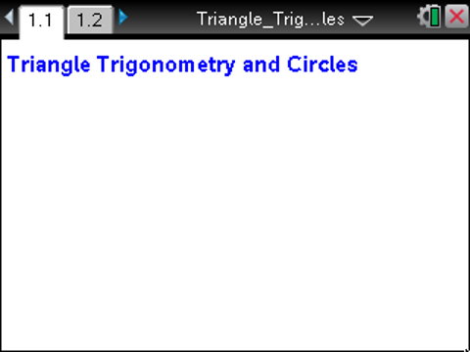
Step 2—Creating Points and Variables  4. Add a new page, and select Add Graphs. | 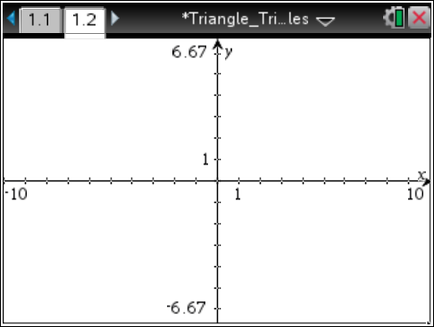
5. Select MENU > Geometry > Points and Lines > Point.  6. Move to the first quadrant of the graph, and click to place a point in that quadrant.  7. Press d to exit the Point application. | 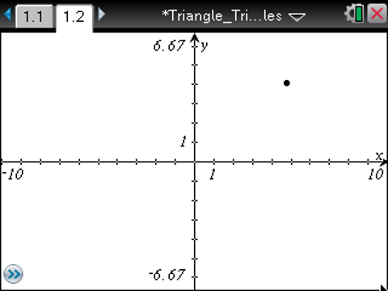
From this point on, directions for the Computer Software and the Handheld will be notated separately where appropriate.  8. Computer Software: Right-click on the point, and select Coordinates and Equations.  Handheld: Hover over the point until { appears. Press /b, and select Coordinates and Equations.  9. Move the coordinates to a convenient location nearby. | 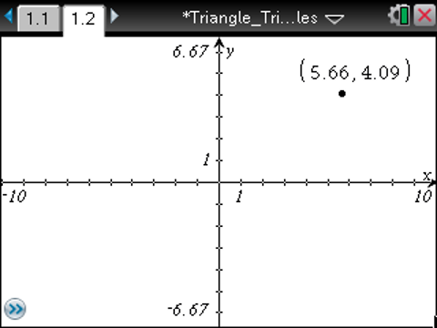
10. Click on the first coordinate of the point to select the value.  - The coordinate will be highlighted in gray when it is selected.  11. Computer Software: Right-click on the coordinate and choose Store.  Handheld: Press /b, and select Store.  - The letters var will appear highlighted. | 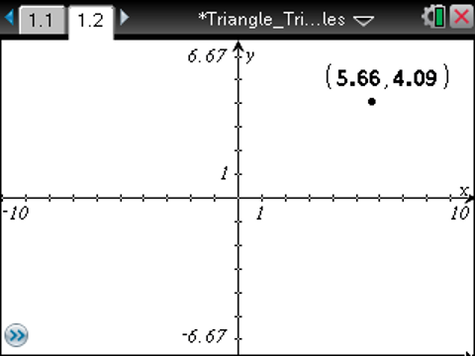
12. Type x to replace var with x, and press Enter (or ·).
- This action stores the value of the first coordinate of the point as x.
13. Repeat the process for the second coordinate, but type y to replace var. This will store the second coordinate of the point as y.

Step 3—Creating a Segment  14. Place a point at the origin. To ensure that the point is at the origin, look for the words “intersection point” to appear as you place the point.  15. Construct a segment between the two points on the graph:  Computer Software: Select Document Tools > Geometry > Points and Lines > Segment. Connect the two points with a segment, and then press Esc to exit the segment tool.  Handheld: Select MENU > Geometry > Points and Lines > Segment. Connect the two points with a segment, and then press d to exit the segment tool. | 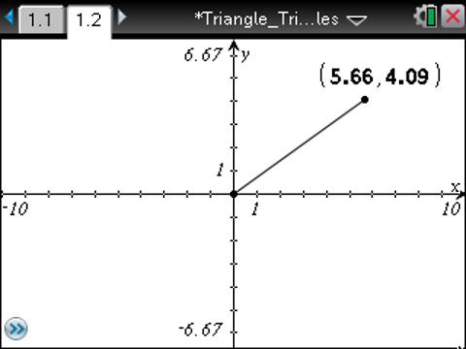
11. Measure the segment just constructed:  Computer Software: Select Document Tools > Geometry > Measurement > Length. Double-click on the segment, and then press Esc to exit the measurement tool.  Handheld: Select MENU > Geometry > Measurement > Length. Double-click on the segment, and then press d to exit the measurement tool.  - A label will appear giving the length of the segment.  12. Store the segment measurement as the variable r:  Computer Software: Right-click on the label for the length of the segment. Select Store, and name the variable r. Be sure to press Enter to save the variable.  Handheld: Select the label for the length of the segment, and press / b. Select Store, and name the variable r. Be sure to press · to save the variable. | 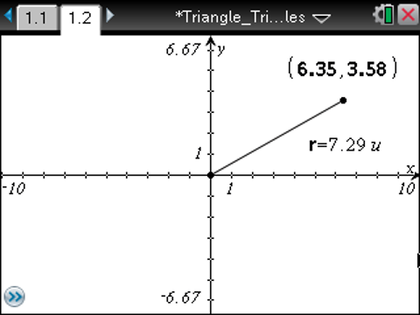
Step 4—Constructing a Circle  13. Construct a circle whose radius is the length of the segment:  Computer Software: Select Document Tools > Geometry > Shapes > Circle. Click first on the point at the origin to mark the center of the circle and then on the other point to mark the radius of your circle. Press Esc to exit the Circle tool.  Handheld: Select MENU > Geometry > Shapes > Circle. Move the pencil cursor to the origin, and click to mark the center of the circle. Move the pencil to the other point to mark the radius of the circle. Press d to exit the Circle tool. | 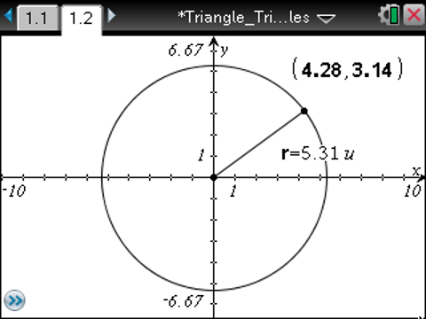
Step 5—Building a Triangle  14. Create a segment perpendicular to the x-axis through the point on the circle:  Computer Software: Select Document Tools > Geometry > Construction > Perpendicular. Click on the point on the circle and then on the x-axis.  Handheld: Select MENU > Geometry > Construction > Perpendicular and then click on the point on the circle and on the x-axis.  - This will construct a line through the point perpendicular to the x-axis. | 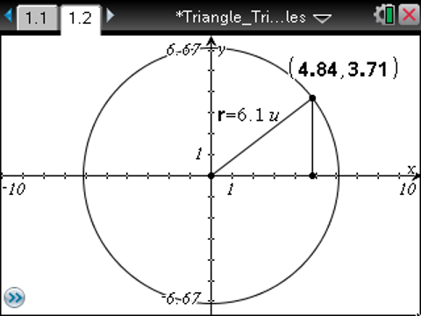
15. Computer Software: Select Document Tools > Geometry > Points & Lines > Segment.
Handheld: Select MENU > Geometry > Points & Lines > Segment.
16. Click on the point on the circle and the intersection of the perpendicular and the x-axis.
17. Press Esc (d) to exit the Segment tool.
18. Finally, right-click (handheld: press /b) on the line (not the segment), and select Hide to hide the line.
19. Build a triangle by constructing the third leg:
Computer Software: Select Document Tools > Geometry > Points & Lines > Segment. Click on the origin first and then the point of intersection between the x-axis and the segment built in the previous step. Press Esc to exit the Segment tool.
Handheld: Select MENU > Geometry > Points & Lines > Segments. Click on the origin first and then the intersection point of the segment and the x-axis. Press d to exit the Segment tool.
20. Fix the angle of the triangle whose vertex is the origin. This will enable the radius to be changed while maintaining similar triangles:
Computer Software: Select Document Tools > Geometry > Measurement > Angle. Select the three points in an order so that the origin is selected second and press Enter. Press Esc to exit the Measurement tool.
Handheld: Select MENU > Geometry > Measurement > Angle, and click the three points in an order so that the origin is selected second. Press ·, and then press d to exit the Measurement tool.
21. Right-click (handheld: press /b) on the value for the angle measure and select Attributes.
22. Click the middle lock icon to change the status to Locked.
23. Right-click (handheld: press /b) on the label, and select Hide to hide it.

Step 6—Setting up Ratios  24. Prepare to measure the ratios of the side lengths by creating labels:  Computer Software: Select Document Tools > Actions > Text. Click once on the graph screen and a textbox appears. Type x / r in the box, and press Enter. Create two more textboxes, one for y / r and one for y / x . Press Esc to exit the Text tool.  Handheld: Select MENU > Actions > Text. Click to create a textbox, type x p r, and press ·. Create two more textboxes, one for y p r and one for y p x. Press d to exit the Text tool.  25. Move the text to the left side of the screen so it does not interfere with the graph. | 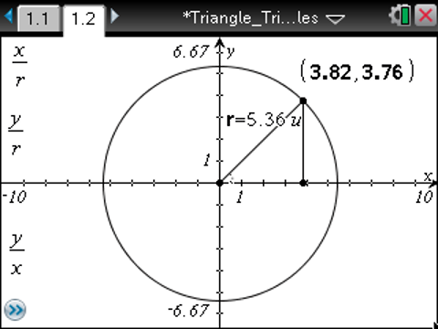
26. Calculate the values of the ratios, and attach them to the labels:  Computer Software: Select Document Tools > Actions > Calculate.  Handheld: Select MENU > Actions > Calculate.  - This will help in observing the effects of changing r on the values of the ratios  27. Click on x/r, click on the value of r, and then click on the x-coordinate of your point.  28. Click close to the label x/r to set the value of the ratio down.  29. Repeat the process for y/r and y/x, selecting the values of the variable correctly as indicated on the screen.  You can now drag the point on the circle and observe the effect on the specified ratios. | 